Yap Dian Hao

A0184679H

C04

CA5

As a computer science student, I took ES1103 under the placement of the QET exam. Initially, I thought this module as merely an unrestricted elective and view its skills learned to be highly specific. Furthermore, as computer science students do not perform a lot of writing tasks, I perceived this module to be a far transfer from the other core modules in my course curriculum. However, as I proceeded throughout the course, I found one of the skills learned, which is integrating sources and expressing stances, to be highly transferable in my coding modules, such as CS2030 Programming Methodology II.

Before I took ES1103, I found my assignments that involve coding to be extremely difficult, and I spent most of my time fixing errors in my code instead of actually learning concepts. As a result, I devoted too much time writing erroneous codes and neglected all of my other modules. I noticed I was lagging behind in my studies, but I could not figure out what was the cause of my problem.

In week 3, I recall that in my “Paraphrasing, Summarizing, Integrating” tutorial session, my tutor Dr. Vivian mentioned about the importance of “making sources talk to each other” when comparing disciplinary texts. In disciplinary texts, the author often utilizes certain key words to express his or her viewpoint on a particular subject, and the usage of these special words are called endorsing and distancing strategies (“Paraphrasing, Summarizing, Integrating”, 2019). These key words can be classified into five distinct categories: evaluative verbs which show the writer’s opinion; intensifiers and limiters which show the degree of distancing and endorsing; modality which shows hedging; concessive clauses which show stances; the passive voice which obscures the author (“Paraphrasing, Summarizing, Integrating”, 2019). Subsequently, we were required to complete a synthesis assignment by comparing several texts to analyze the different stances of the authors, and as I tried applying these strategies to my coding assignments, I realized my mistake all along.

In the computer science curriculum, we are required to conduct extensive amount of research to achieve certain tasks in programming. Along our journey, we are bound to encounter various kinds of errors, and have to look for online source codes as a reference to fix them. Before I applied the endorsing and distancing strategies in CS2030, I used to search for the errors I encountered in the world’s largest developers’ forum, Stack Overflow and blindly grab any reference code that is available and tailor it to my needs. Since I applied the identifying of the endorsing and distancing strategies, I am more capable of selecting the best and the most suitable solution. As forum posts in Stack Overflow include comments and interactions from developers worldwide, I am able to filter out the solutions by scanning through the comments and identify keywords that fell under the five distinct categories. For instance, I found a forum post that answers one of my questions about a peculiar behavior of a computer language (see Figure 1). However, the answers to the post vary, and I am unable to decide on the explanation behind it. Fortunately, I am able to analyze each answers’ line of reasoning and shortcomings with the endorsing and distancing toolkit in ES1103. For example, a reply to a post that contains the word “while” followed by explanations indicates that the current answer provided has its limitations, and I should continue to delve deeper and search until a satisfied solution is found. Figure 2 shows an example of the usage of the concessive clause “while” (underlined in black) which indicates there is some degree of doubt to the current solution (“Paraphrasing, Summarizing, Integrating”, 2019).

After learning this critical skill in ES1103, I found it to be fruitful in computer science. Ever since I applied it in coding, my learning pace improved. I was able to finish assignments on time, scored better grades and most importantly, I am actually learning concepts by using the accurate and valuable insights gained from the forum. Although ES1103 seemed like a far transfer from my modules in the start, I am grateful I am able to hone my analytical skills by determining different stances with the endorsing and distancing strategies, and I am certain this valuable skillset learned from ES1103 will not only benefit me in my current modules, but also in many future courses and even in the long run.

(750 words)

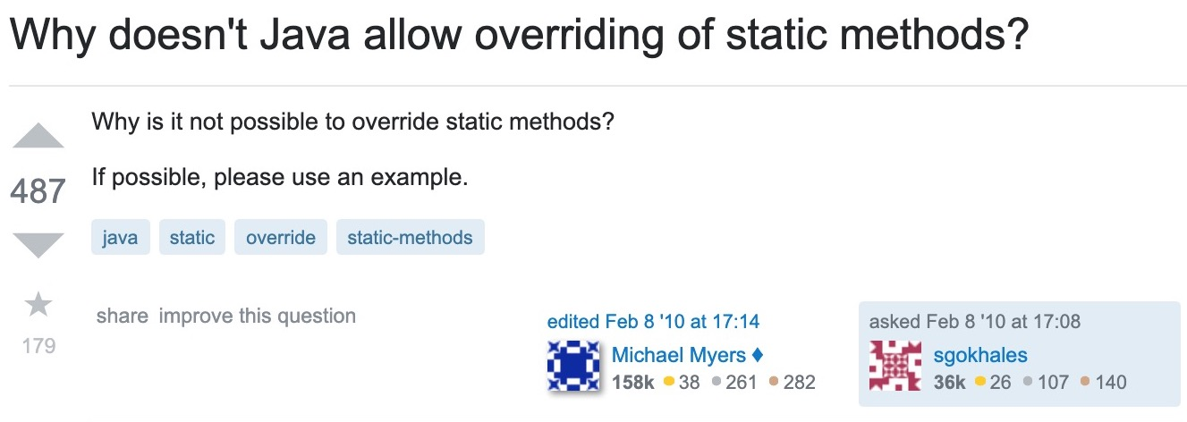

Figure 1. [Why doesn't Java allow overriding of static methods?](https://stackoverflow.com/questions/2223386/why-doesnt-java-allow-overriding-of-static-methods) (StackOverflow, 2010)

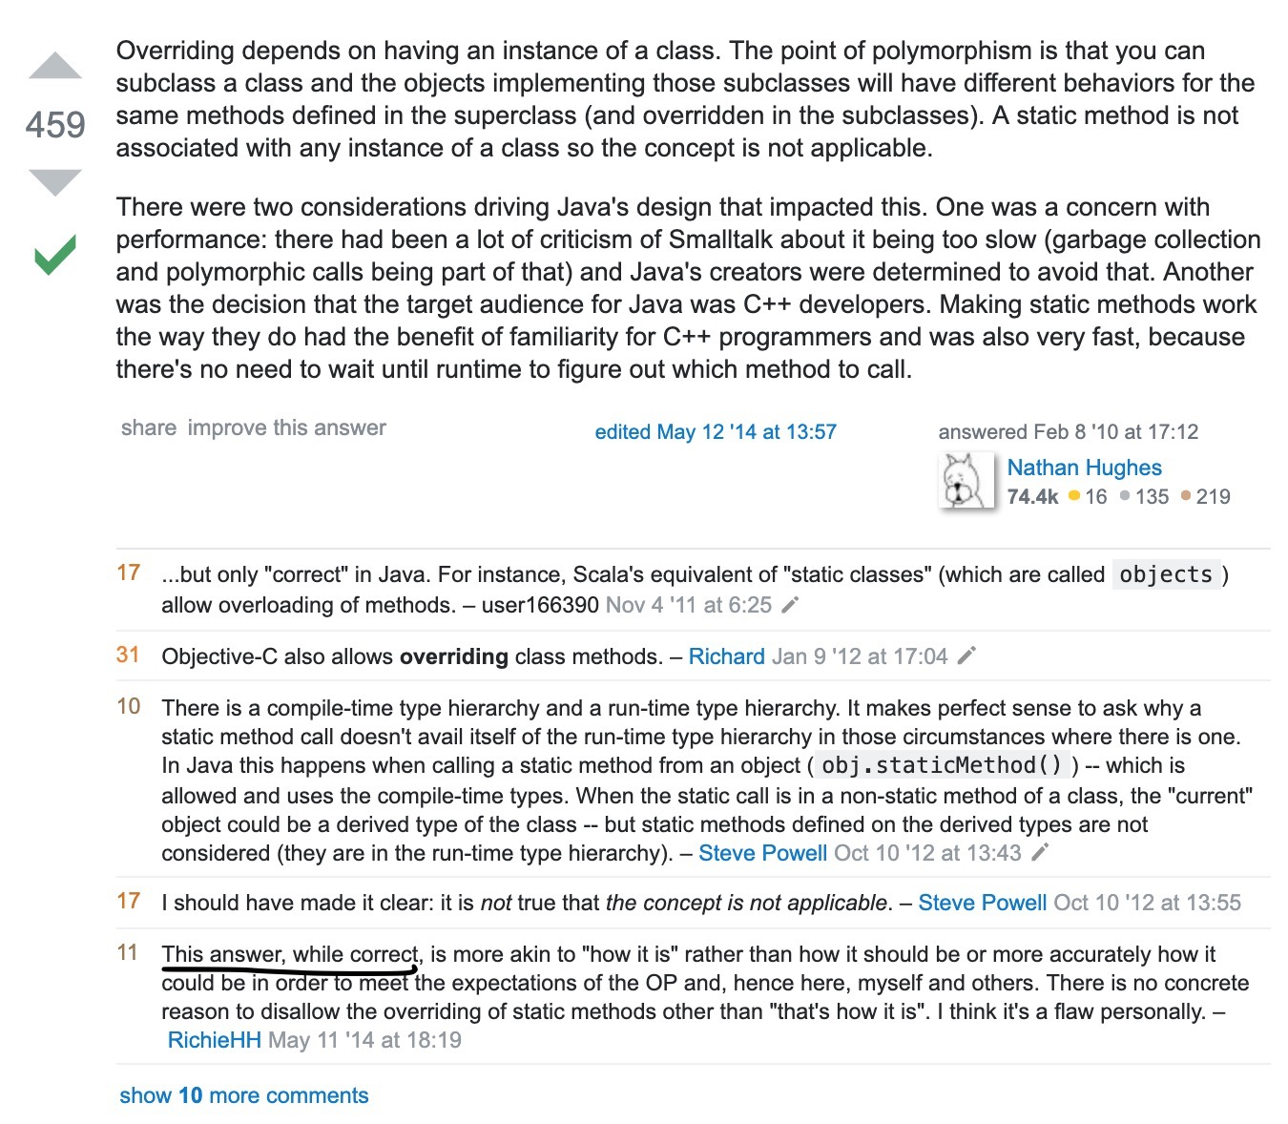

Figure 2. [Why doesn't Java allow overriding of static methods?](https://stackoverflow.com/questions/2223386/why-doesnt-java-allow-overriding-of-static-methods)

(StackOverflow, 2010)

Reference List:

Paraphrasing, Summarizing; Integrating Sources and Expressing Stance (2019). ES1103 English for Academic Purposes [Class Handout]. CELC, National University of Singapore.

Stack Overflow (2010). Why Doesn’t Java Allow Overriding of Static Methods?

Retrieved from <https://stackoverflow.com/questions/2223386/why-doesnt-java-allow-overriding-of-static-methods>